Singleton Pattern Example Output:

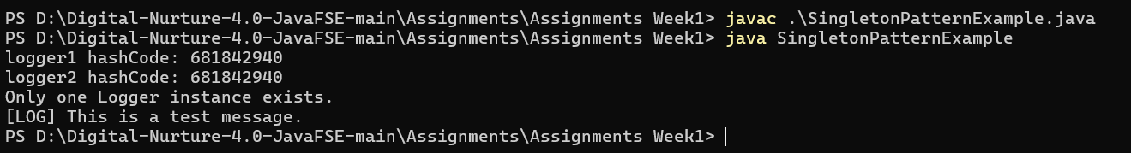

Factory Method Pattern Example Output:

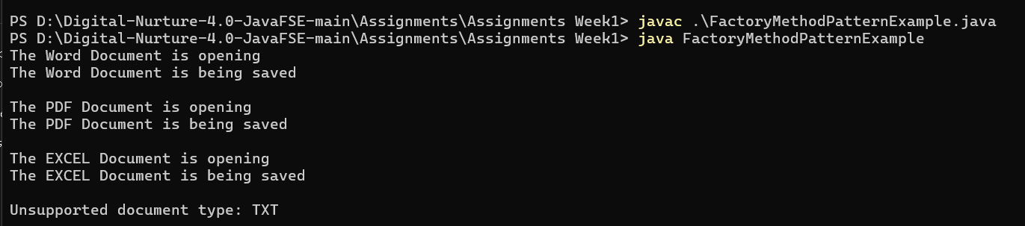

Ecommerce Platform Search:



Inventory Management System:

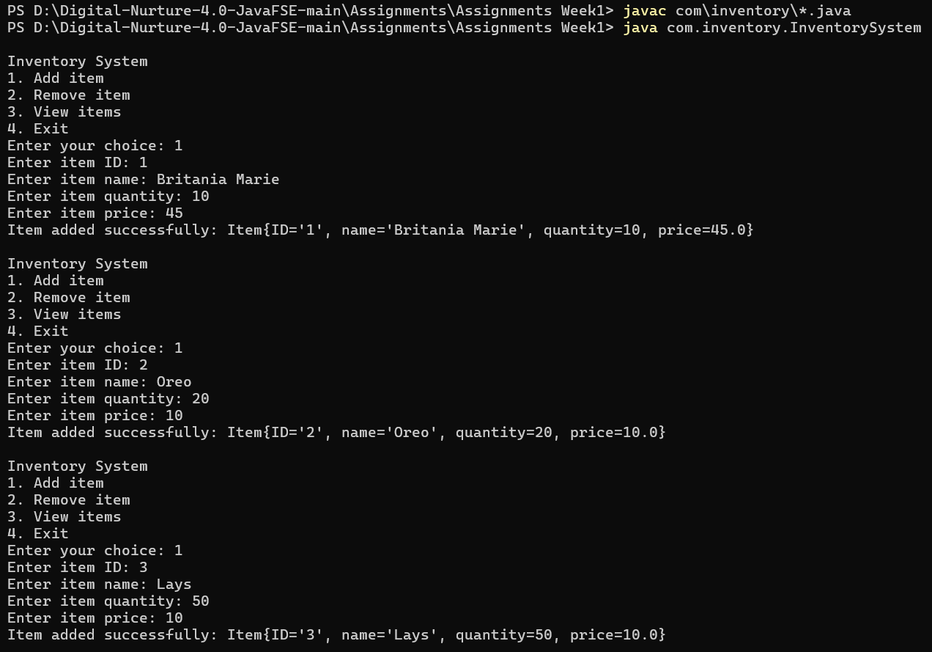

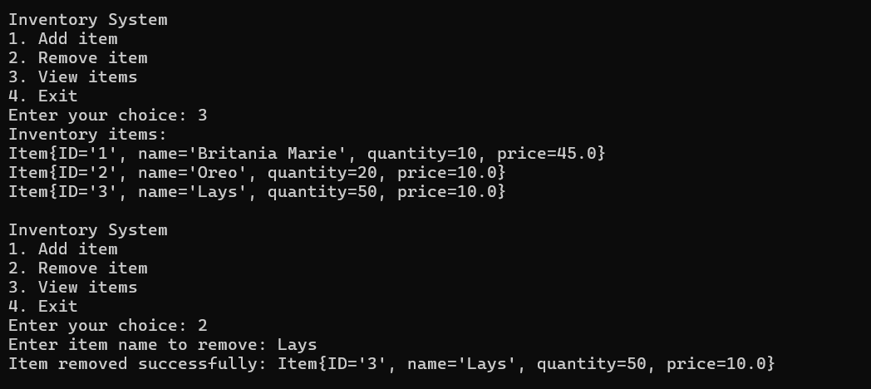

Financial Forecasting

